SIT725 – Applied Software Engineering

Task 6.2D – Testing

GitHub Link:

<https://github.com/Screwlogist/SIT725.git>

Screenshots:

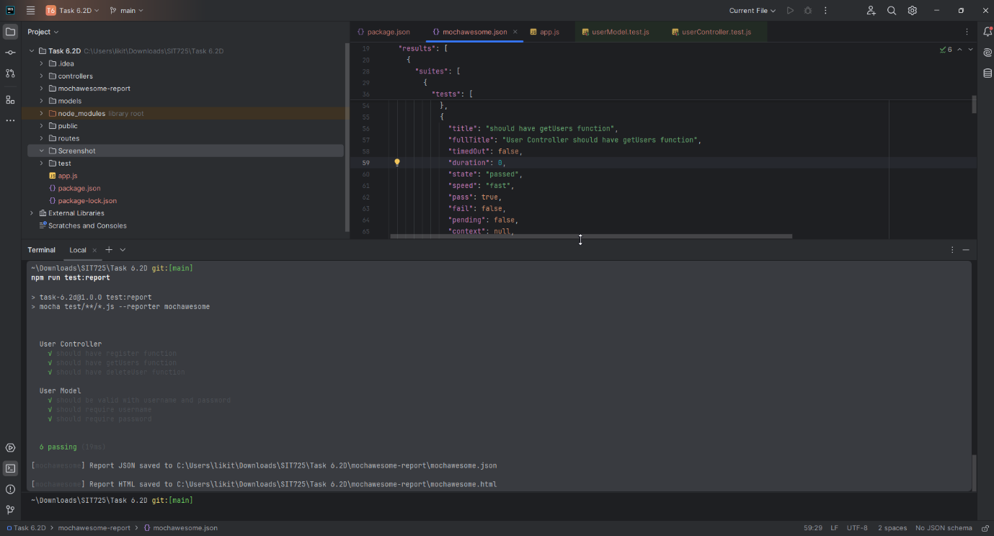

**Description:** The screenshot displays a successful test run of an MVC application with all six tests passing for both the User Controller and User Model components. The Mochawesome reporter has generated comprehensive JSON and HTML reports documenting the test results, confirming proper implementation of the application's core functionality.